**USER MANUAL FOR LOCKER WITH SPECIAL NEEDS IN DEPEW HIGH SCHOOL**

**Prepared By:**

**Tijmen Van Der Beek, Siquan Wang, Miren Patel, Xiaoang Zhang, Dazhou Liu**

*School of Engineering and Applied Sciences*

*University at Buffalo, The State University of New York*

*Spring 2021*

**Contents**

**1 Introduction** **2**

**2 Locker Usage** **2**

**2.1 Locker Activation 2**

**2.2 Unlocking 2**

**2.3 Locking 3**

**2.4 Clearing and Registering Tags 3**

**3 LED Status** **4**

**4 Speaker Sound Clarifications** **5**

**5 Mechanical Override** **5**

**6 Power Source Manipulation** **5**

**7 Troubleshootings** **6**

**8 Safety Information 6**

# 

# **1 Introduction**

Based on feedback provided by clients, this electrical locker system is designed with customized functions to assist students having trouble accessing a mechanical locker. By using this locker system, a user (student) is able to gain access to their locker without challenges.

To facilitate users to transit to this new locker system, this user manual includes descriptions of the electronic components, procedures of using the locker system and troubleshootings for possible failures. Photos of system components are also included to make this user manual intuitive.

# **2 Locker Usage**

## 2.1 Locker Activation

Pressing the button on the front panel of the locker door activates the locker system. A LED enclosed inside the locker door then becomes red to indicate that the locker is ready to read tags but is locked. A speaker also produces sound to indicate this status. If the locker is idle for 30 seconds it will turn off automatically.

## 2.2 Unlocking

To unlock, an authorized RFID tag must be scanned on the front panel. The LED’s color turns to green and the speaker produces a sound to indicate the unlocking status. At this point, the user needs to push the locker door. Then the locker door pops out automatically, and the user gains access to their stuff in the locker.

## 2.3 Locking

If no action is taken by the user after 10 seconds upon unlocking, the solenoid will automatically lock. Afterwards, the user needs to lock the locker door again by pressing it back to the initial position. You can also press the button again to lock the locker earlier.

## 2.4 Clearing and Registering Tags

To register a tag, first turn on the locker, unlock it if the door is closed. **Once the door is open, reactivate the locker in locked mode.** Press the button on the inside panel of the locker with a pencil. **(Don’t press with too much force)** Once the button has been pressed the led will turn blue indicating it is ready to register a tag. Scan the tag you want to register, if the led blinks blue it has registered successfully. You can register up to 32 tags to one locker.

To clear the tags registered to the locker press the button on the back of the locker twice. Once it was pressed the second time the locker led should blink pink twice this indicates that there are no registered tags to the locker. Make sure to register another tag before closing the locker.

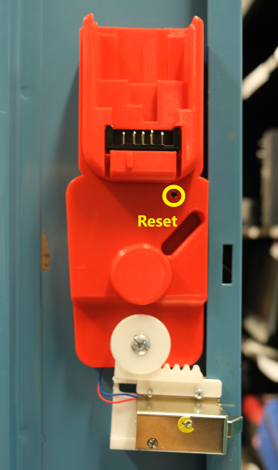

# **3 LED Status**

There are two LEDs on the front panel.

* The left LED (right above the push button) indicates the status of the locker system.

|  |  |
| --- | --- |
| **LED Colors** | **Locker Status** |
| OFF | Initial Status |
| RED | Push button pressed, circuit turned on and ready to read the tags. |
| Blinking RED | Wrong tag detected |
| GREEN | Unlocked |
| Blinking Green | Correct Tag unlocking |
| Blue | Register Mode |
| Blinking Blue | Successful Tag register |
| Blinking Pink | Clearing all tags |

* The right LED indicates the voltage level of the DeWalt battery.

|  |  |
| --- | --- |
| **LED Colors** | **Battery Status** |
| Initial Status | Off |
| GREEN | Battery level sufficient (battery voltage greater than 10V) |
| RED | Battery is low (battery voltage less than 8V but greater than 7V) The battery needs to be charged. |
| Blinking Red | Battery is low (battery voltage less than 7 V). At this point, the locker will turn off after blinking red. |
| Off | Off |

# **4 Speaker Sound Clarifications**

A speaker is embedded to facilitate users with hearing impairment. There are three types of speaker sound, indicating different locker status.

* Sound when locker initialized
* Sound when unlocked
* Sound when error occured

# **5 Mechanical Override**

Mechanical override is a solution to unlock the door for emergency situations (power failure or lost tags). The core components are two gears that are able to slide the solenoid horizontally.

A key is used to unlock externally, and the position of inserting the key is a keyhole located below the red push button on the front panel. When unlocking by mechanical override, the user first inserts the key, **presses in the locker door** and turns it counterclockwise. Upon successful unlocking, the user must turn the key clockwise to the initial position so that the locker is locked again.

# **6 Power Source Manipulation**

The power source of each locker is a DeWalt 12V battery, and it does not utilize wall power. When exhausted, the battery inside the locker door needs to be detached and charged in the DeWalt Battery Charger.

By fully charging the DeWalt 12V battery, the locker circuits can be supported for approximately 3 months, assuming each user unlocks five times a day.

In case of power failure of the DeWalt 12V battery, mechanical override is required to unlock the locker for further actions.

# **7 Troubleshootings**

* If the locker turns on but doesn't seem to work properly try recharging the battery.
* If the solenoid stops working when the locker is unlocked try recharging the battery.
* If the locker is blinking red or not turning on when pressing the power button try recharging the battery.
* If the locker is not turning on try pushing in the dewalt battery completely.
* If the solenoid latch is stuck in unlock position, easily tab the solenoid case to reset back to lock position.

# 

# **8 Safety Information**

Most of the wires and electronic components are enclosed inside cases. But one portion of a wire that connects to the solenoid may be exposed. Be careful to avoid contacting that wire.